Program Information
Program Name | Program License Number
Program Address

Program Email | Program Phone Number
Program Contact Name | Submitted for the Week of
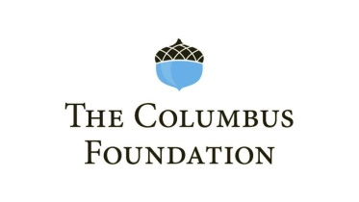
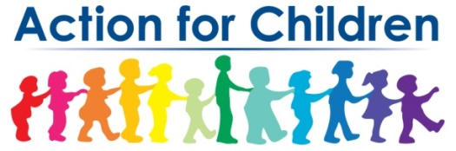
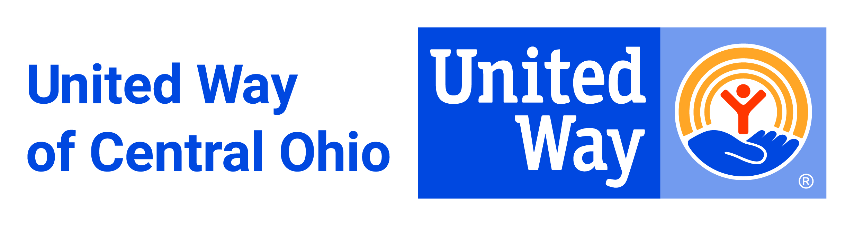
Child Care Affordability (CCAS)
Weekly Enrollment Verification

Please submit this form in weekly to scholarships@actionforchildren.org by 12 noon every Monday for prompt payment processing

 | Child Last Name | Child First Name | Child Date of Birth | Parent Last Name | Parent First Name | Current PFCC Recipient (Y/N) | Current Weekly Tuition Amount | Enrollment Begin Date | Enrollment End Date
1
2
3
4
5
6

Signature of Owner or Administrator | Date
By signing below, I certify that all information is true and correct. I understand that if the information provided herein is incorrect, I may be required to forfeit the scholarship and repay any scholarship funds already expended [to me/on my behalf] at the time when the inaccuracy is discovered.

