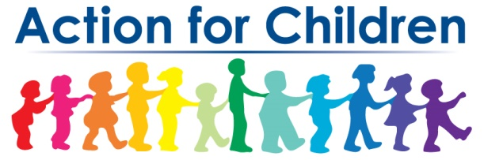
Child Care Affordability
Scholarship (CCAS)
Income Verification

The Child Care Affordability Scholarship (CCAS) is made possible with funding from The Columbus Foundation and United Way of Central Ohio.

Child(ren) Name(s) |  |  | Parent’s Name(s)
Current Address
Email Address |  |  | Phone Number
Name and Address of Child Care Program
Is Your Child(ren) Currently Receiving Publicly Funded Child Care (PFCC)?  Check One:  - Yes  - No | Family Size | Find your Household/Family Size in the Chart Below. Is Your Combined Income Below These Annual or Monthly Limits? Check the One:  - Under 200% Federal Poverty Level  - Under 300% Federal Poverty Level

Household/  Family Size | 200% Federal Poverty Level* |  | 300% Federal Poverty Level*
 | Annually | Monthly | Annually | Monthly
1 | $25,520 | $2,127 | $38,280 | $3,190
2 | $34,480 | $2,873 | $51,720 | $4,310
3 | $43,440 | $3,620 | $65,160 | $5,430
4 | $52,400 | $4,367 | $78,600 | $6,550
5 | $61,360 | $5,113 | $92,040 | $7,670
6 | $70,320 | $5,860 | $105,480 | $8,790
7 | $79,280 | $6,607 | $118,920 | $9,910
8 | $88,240 | $7,353 | $132,360 | $11,030
9 | $97,200 | $8,100 | $145,800 | $12,150
10 | $106,160 | $8,847 | $159,240 | $13,270
* 2020 U.S. Federal Poverty Guidelines, All States (except Alaska and Hawaii), Department of Health and Human Services

Signature of Parent | Date
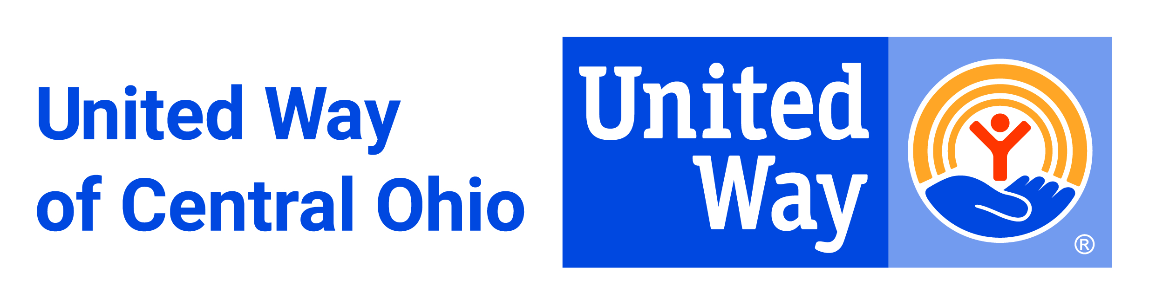
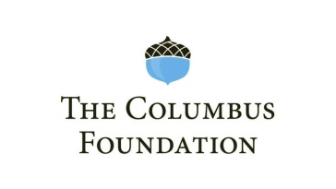
By signing below, I certify that all information is true and correct. I understand that if the information provided herein is incorrect, I may be required to forfeit the scholarship and repay any scholarship funds already expended [to me/on my behalf] at the time when the inaccuracy is discovered.

